1)Airthmetic Exception

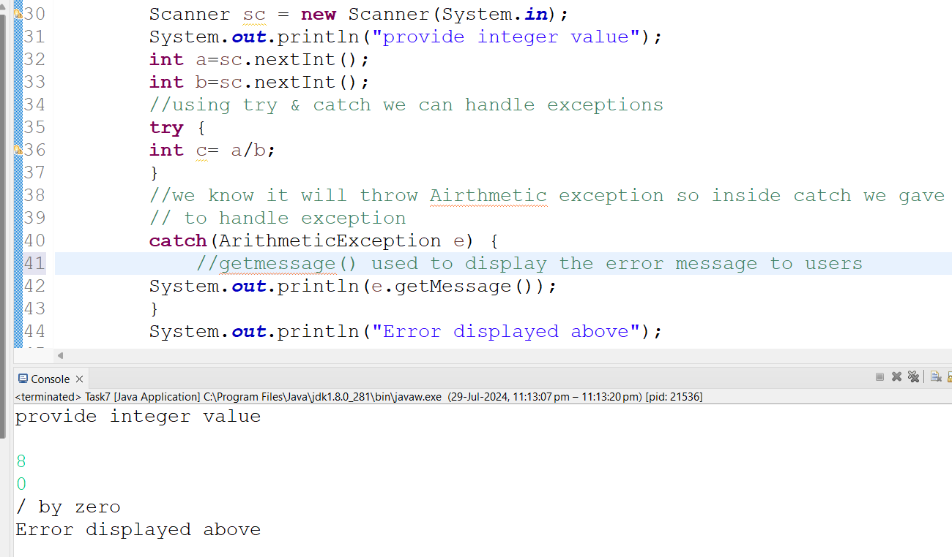

2)Array Out of Bound Exception

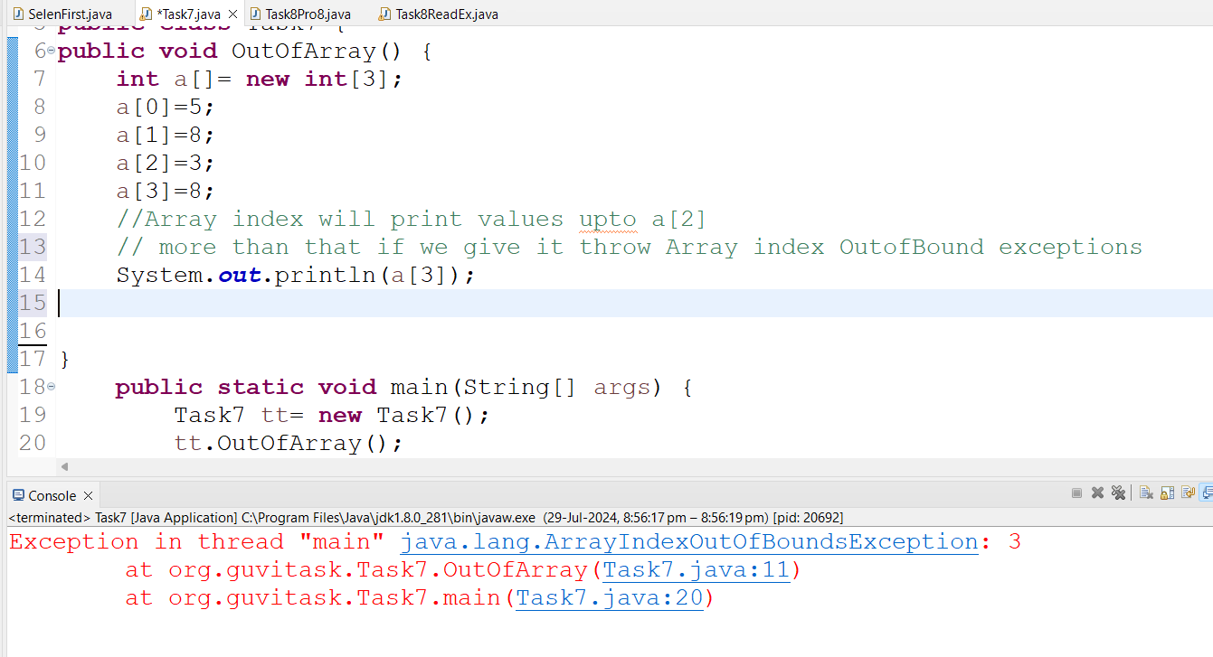

String out of bound exceptions:

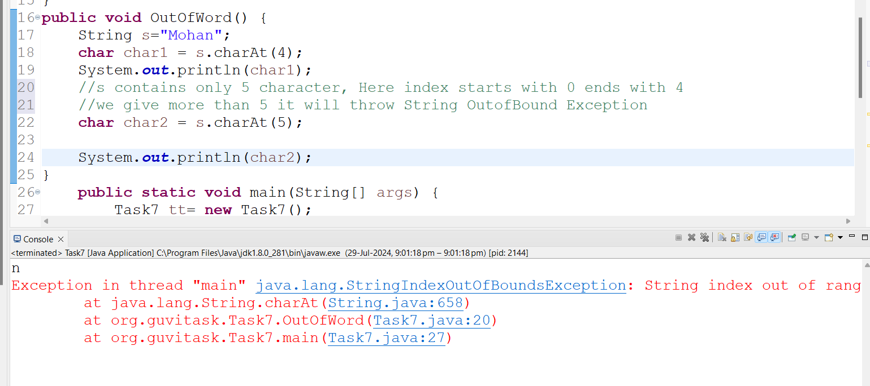

3)Invalid Age Exception:

There is no “invalidageexception” class, So we need to create new class and use that class whenever we required.

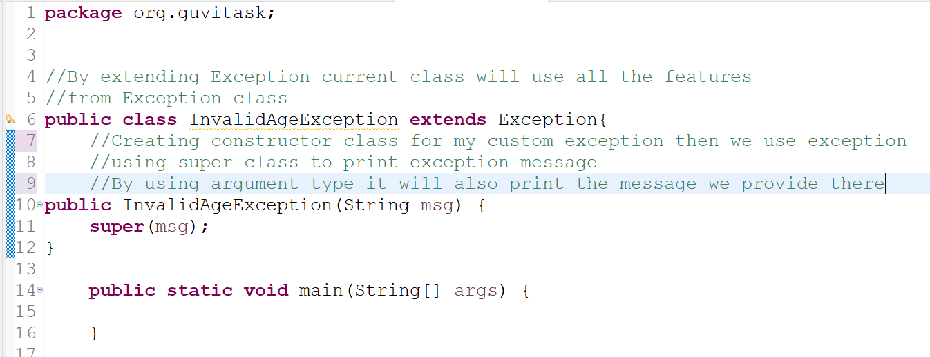

If Age is below 18 it should throw InvalidAgeException error

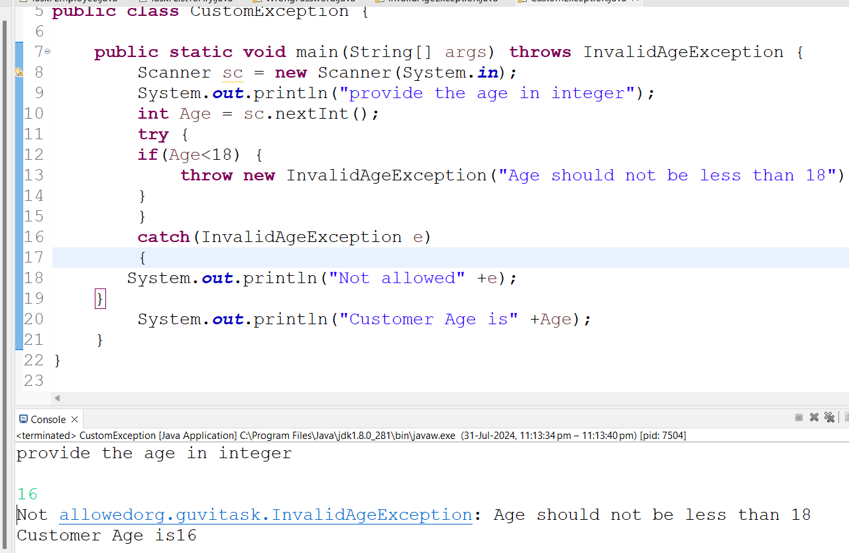

If age is not less than 18 it should not throw InvalidAgeException

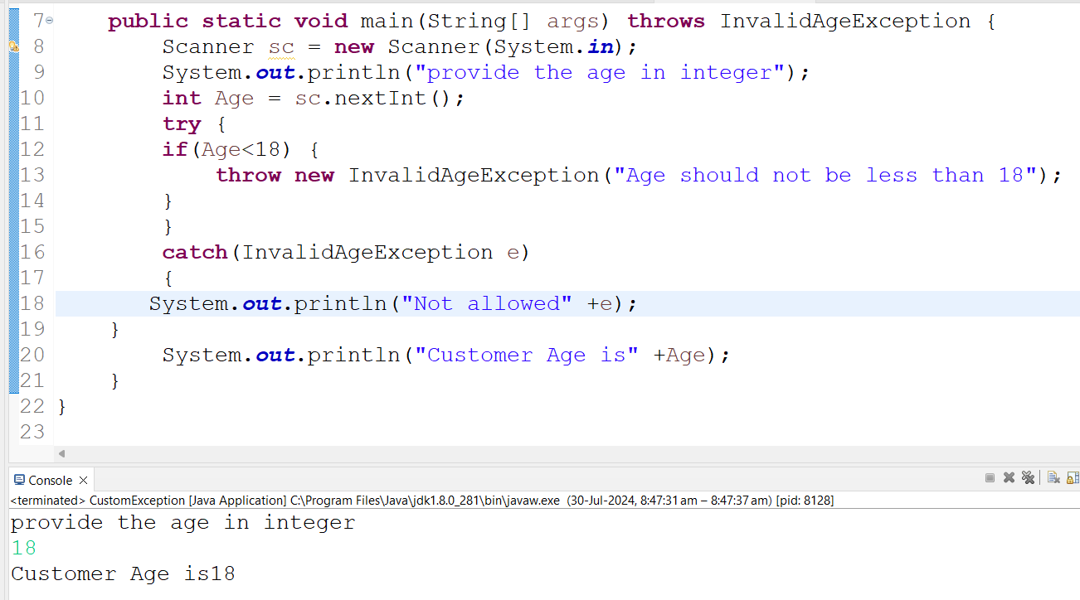

4) FileNotFound Exception

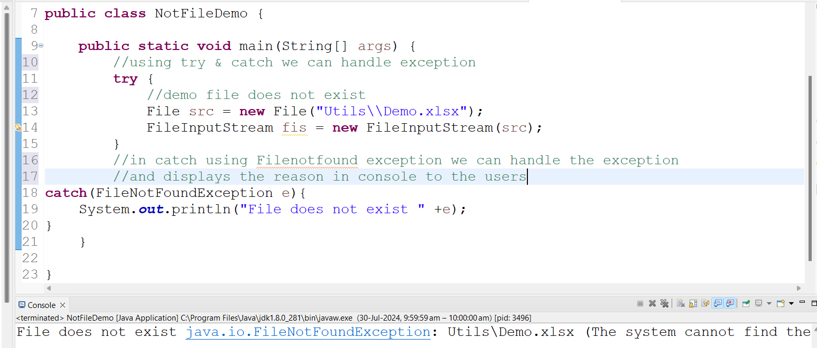

5) Arraylist using clear() method, cleared all the values from the arraylist. After printing it displays empty ex[] array.

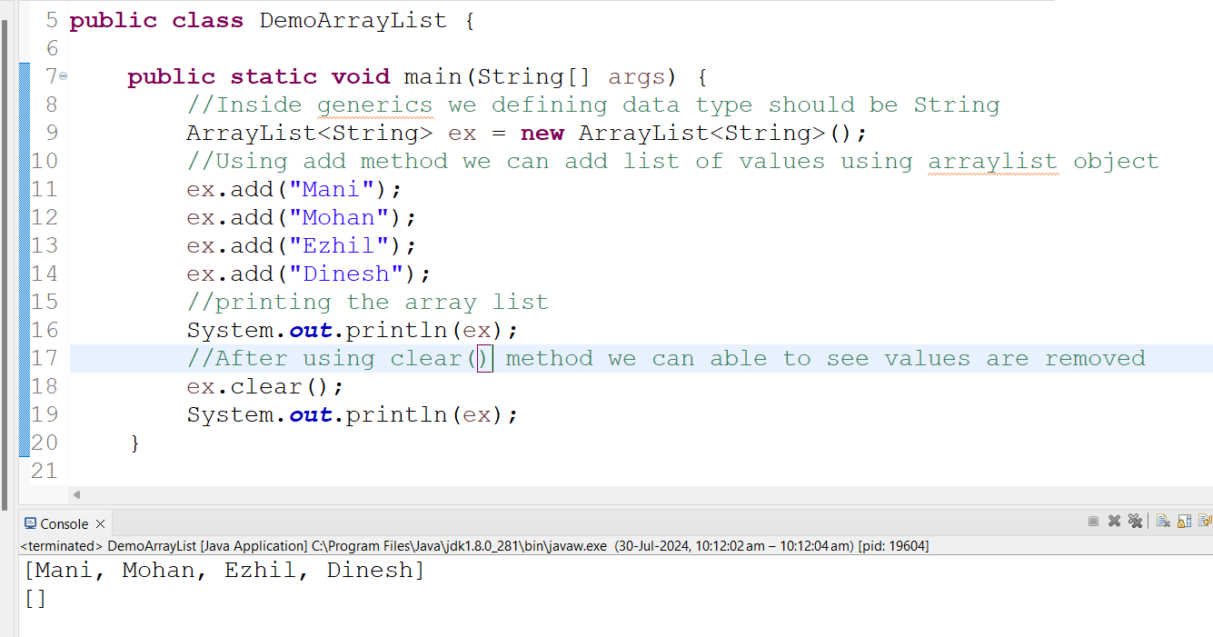

6) Treemap:

Treemap will be in ascending order based on key

Key won’t allow null value.

Value allow the duplicate null

Note: Using enhanced For loop will get the data one by one and displayed the result of employees name using getkey() method.

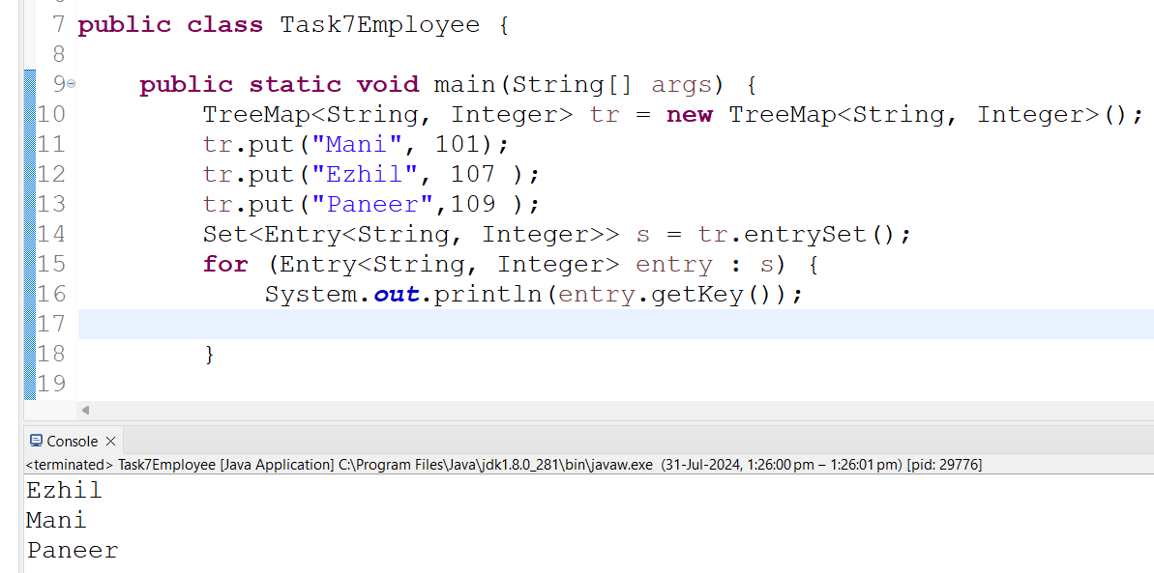

7)List to Array

